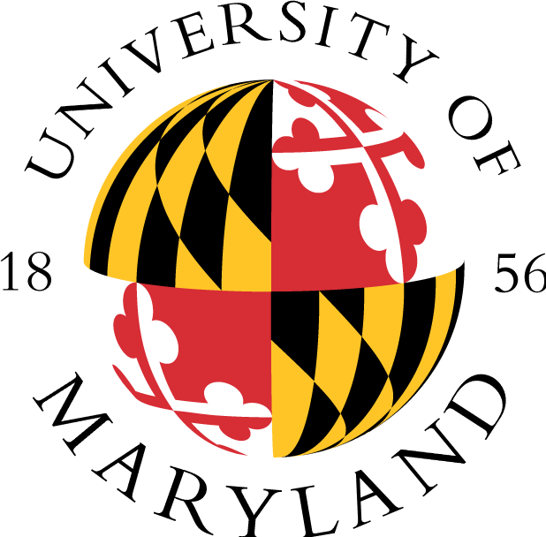

ACADEMIC ACHIEVEMENT PROGRAMS
Ronald E. McNair Post-Baccalaureate Achievement Program
2110 Marie Mount Hall * College Park, MD 20742
(P) 301.405.4749 * (F) 301.314.7255 * mcnairscholar@umd.edu
www.aap.umd.edu/mcnairprogram.html

VERIFICATION OF GRADUATION OR ENROLLMENT

Purpose of this Form: The McNair Scholars Program is a federally-funded TRiO program. Each year, the program is required to report to the U.S. Department of Education the students who received their degrees or enrolled in a graduate program. Please assist us by providing the information below. The information below is requested because we are unable to contact the student directly; therefore, your assistance is appreciated. You may contact us if you have any questions or require any additional information. Thank you in advance for your time.

PERMISSION FROM STUDENT

I, __________________________________________________________________, give the University of Maryland McNair Scholars Program permission to contact my undergraduate institution and my self-reported graduate institution to receive the following information: 1) verification of enrollment, 2) verification of type of degree completed, and 3) verification of date degree awarded.

_________________________________________________________ ________________________________________________________
Signature Date Signed

Date of request
Sent to Office of the Registrar at
Regarding student
Last four digits of SSN
Request sent by | Wallace Southerland III, Ph.D.  Associate Director, McNair Scholars Program

Please complete the information at the bottom and return as fax or scan and send via email. Contact information is on the letterhead.

TO BE COMPLETED BY RECEIVING INSTITUTION

Institution
Date degree awarded
Type of degree awarded
Contact Person

